**Pemrogramman 4**

**praktikum 4**

**Nama : Muhammad Sidratul Muntaha**

**Npm : 4510210013**

**Screenshoot**

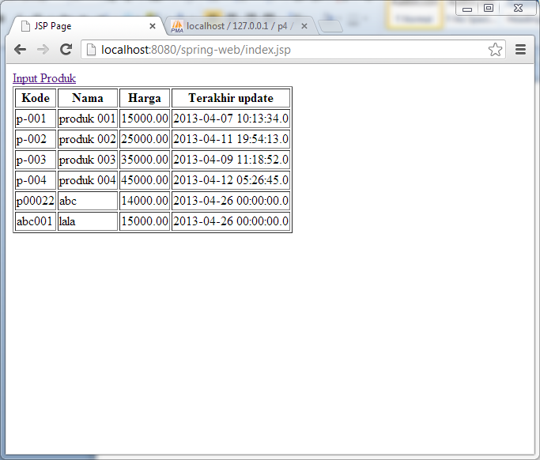

**Gambar 1.** tampilan awal

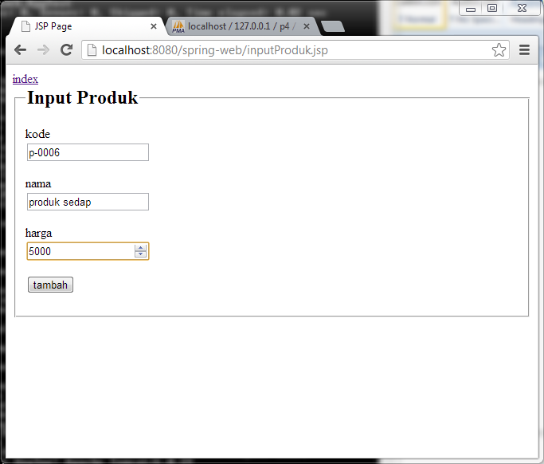

**Gambar 2.** Tampilan input produk

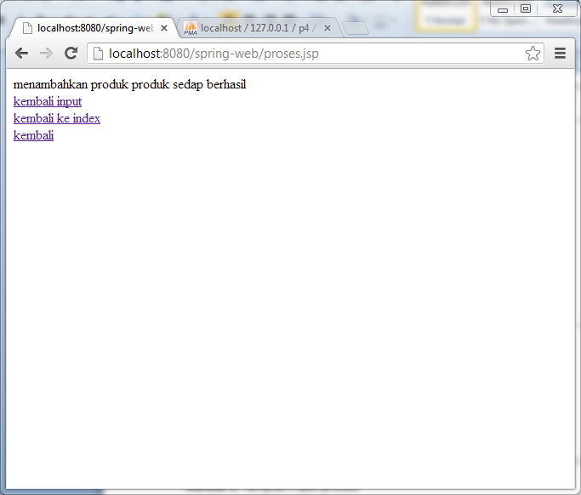

**Gambar 3.** servlet input

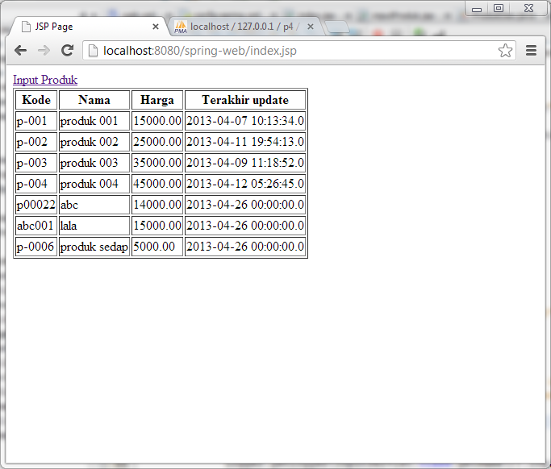

**Gambar 4.** Hasil input

**Source Code**

* pom.xml

|  |
| --- |
| <project xmlns="http://maven.apache.org/POM/4.0.0" xmlns:xsi="http://www.w3.org/2001/XMLSchema-instance"  xsi:schemaLocation="http://maven.apache.org/POM/4.0.0 http://maven.apache.org/xsd/maven-4.0.0.xsd">  <modelVersion>4.0.0</modelVersion>  <groupId>com.p4.springweb</groupId>  <artifactId>spring-web</artifactId>  <version>1.0-SNAPSHOT</version>  <packaging>war</packaging>  <name>spring-web</name>  <url>http://maven.apache.org</url>  <properties>  <project.build.sourceEncoding>UTF-8</project.build.sourceEncoding>  </properties>  <dependencies>  <dependency>  <groupId>junit</groupId>  <artifactId>junit</artifactId>  <version>3.8.1</version>  <scope>test</scope>  </dependency>  <dependency>  <groupId>org.springframework</groupId>  <artifactId>spring-webmvc</artifactId>  <version>3.2.1.RELEASE</version>  </dependency>  <dependency>  <groupId>jstl</groupId>  <artifactId>jstl</artifactId>  <version>1.2</version>  </dependency>    <dependency>  <groupId>mysql</groupId>  <artifactId>mysql-connector-java</artifactId>  <version>5.1.23</version>  </dependency>  <dependency>  <groupId>javax.servlet</groupId>  <artifactId>javax.servlet-api</artifactId>  <version>3.1-b06</version>  <scope>provided</scope>  </dependency>  <dependency>  <groupId>commons-dbcp</groupId>  <artifactId>commons-dbcp</artifactId>  <version>1.4</version>  </dependency>  <dependency>  <groupId>org.springframework</groupId>  <artifactId>spring-jdbc</artifactId>  <version>3.2.1.RELEASE</version>  </dependency>  <dependency>  <groupId>org.springframework</groupId>  <artifactId>spring-context</artifactId>  <version>3.2.2.RELEASE</version>  </dependency>  </dependencies>  </project> |

* web.xml

|  |
| --- |
| <?xml version="1.0" encoding="UTF-8"?>  <web-app version="2.5" xmlns="http://java.sun.com/xml/ns/javaee" xmlns:xsi="http://www.w3.org/2001/XMLSchema-instance" xsi:schemaLocation="http://java.sun.com/xml/ns/javaee http://java.sun.com/xml/ns/javaee/web-app_2_5.xsd">    <servlet>  <servlet-name>input-produk</servlet-name>  <servlet-class>com.p4.springweb.InputServlet</servlet-class>  </servlet>  <servlet-mapping>  <servlet-name>input-produk</servlet-name>  <url-pattern>/proses.jsp</url-pattern>  </servlet-mapping>  </web-app> |

* index.jsp

|  |
| --- |
| <%--  Document : inputProduk  Created on : Apr 26, 2013, 2:19:46 PM  Author : Muhammad Sidratul M  --%>  <%@ page import="java.io.*,java.util.*,java.sql.*"%>  <%@ taglib uri="http://java.sun.com/jsp/jstl/core" prefix="c"%>  <%@ taglib uri="http://java.sun.com/jsp/jstl/sql" prefix="sql"%>  <%@page contentType="text/html" pageEncoding="UTF-8"%>  <!DOCTYPE html>  <html>  <head>  <meta http-equiv="Content-Type" content="text/html; charset=UTF-8">  <title>JSP Page</title>  </head>  <body>  <a href="inputProduk.jsp">Input Produk</a>  <sql:setDataSource var="db" driver="com.mysql.jdbc.Driver" url="jdbc:mysql://localhost/p4" user="root" password=""/>  <sql:query dataSource="${db}" var="hasil">SELECT * FROM produk;</sql:query>  <table border="1">  <tr>  <th>Kode</th>  <th>Nama</th>  <th>Harga</th>  <th>Terakhir update</th>  </tr>  <c:forEach var="data" items="${hasil.rows}">  <tr>  <td><c:out value="${data.kode}"/></td>  <td><c:out value="${data.nama}"/></td>  <td><c:out value="${data.harga}"/></td>  <td><c:out value="${data.terakhir_update}"/></td>  </tr>  </c:forEach>  </table>  </body>  </html> |

* inputProduk.jsp

|  |
| --- |
| <%--  Document : inputProduk  Created on : Apr 26, 2013, 2:19:46 PM  Author : Muhammad Sidratul M  --%>  <%@page contentType="text/html" pageEncoding="UTF-8"%>  <!DOCTYPE html>  <html>  <head>  <meta http-equiv="Content-Type" content="text/html; charset=UTF-8">  <title>JSP Page</title>  </head>  <body>  <a href="index.jsp">index</a>  <form action="proses.jsp" method="POST">  <fieldset>  <legend><h2>Input Produk</h2></legend>  <p>  <div><label name="kode">kode</label></div>  <input type="text" name="kode" required="required"/>  </p>  <p>  <div><label name="mama">nama</label></div>  <input type="text" name="nama" required="required"/>  </p>  <p>  <div><label name="harga">harga</label></div>  <input type="number" name="harga" required="required"/>  </p>  <p>  <input type="submit" value="tambah">  </p>  </fieldset>  </form>  </body>  </html> |

* Produk.java

|  |
| --- |
| /*  * To change this template, choose Tools | Templates  * and open the template in the editor.  */  package com.p4.springweb;  import java.math.BigDecimal;  import java.util.Date;  /**  *  * @author Muhammad Sidratul M  */  public class Produk {  private Integer id;  private String kode;  private String nama;  private BigDecimal harga;  private Date terakhirUpdate;  public BigDecimal getHarga() {  return harga;  }  public void setHarga(BigDecimal harga) {  this.harga = harga;  }  public Integer getId() {  return id;  }  public void setId(Integer id) {  this.id = id;  }  public String getKode() {  return kode;  }  public void setKode(String kode) {  this.kode = kode;  }  public String getNama() {  return nama;  }  public void setNama(String nama) {  this.nama = nama;  }  public Date getTerakhirUpdate() {  return terakhirUpdate;  }  public void setTerakhirUpdate(Date terakhirUpdate) {  this.terakhirUpdate = terakhirUpdate;  }  } |

* ProdukDao.java

|  |
| --- |
| /*  * To change this template, choose Tools | Templates  * and open the template in the editor.  */  package com.p4.springweb;  import java.math.BigDecimal;  import java.sql.PreparedStatement;  import java.sql.ResultSet;  import java.util.ArrayList;  import java.util.List;  import javax.sql.DataSource;  /**  *  * @author Muhammad Sidratul M  */  public class ProdukDao {  private DataSource dataSource;  private PreparedStatement psInsert;  private PreparedStatement psUpdate;  private PreparedStatement psTampil;  private int hasil;  public void setDataSource(DataSource dataSource) throws Exception {  this.dataSource = dataSource;    String sqlInsert = "INSERT INTO `produk`(`kode`, `nama`, `harga`, `terakhir_update`) VALUES (?,?,?,?)";  String sqlUpdate = "UPDATE `produk` SET `id`=?,`kode`=?,`nama`=?,`harga`=?,`terakhir_update`=[value-5] WHERE id=?";  String sqlTampil = "SELECT * FROM produk";    psInsert = dataSource.getConnection().prepareStatement(sqlInsert);  psUpdate = dataSource.getConnection().prepareStatement(sqlUpdate);  psTampil = dataSource.getConnection().prepareStatement(sqlTampil);  }    public void simpan(Produk p)throws Exception{  psInsert.setString(1,p.getKode());  psInsert.setString(2,p.getNama());  psInsert.setBigDecimal(3,p.getHarga());  psInsert.setDate(4,new java.sql.Date(p.getTerakhirUpdate().getTime()));    hasil = psInsert.executeUpdate();  }    public Integer getHasil(){  return hasil;  }    /*public List<Produk> tampilProduk() throws Exception{  List<Produk> hasil = new ArrayList<Produk>();    ResultSet rs = psTampil.executeQuery();  while(rs.next()){  Produk p = new Produk();  p.setId(rs.getInt("id"));  p.setKode(rs.getString("kode"));  p.setNama(rs.getString("nama"));  p.setHarga(rs.getBigDecimal("harga"));  p.setTerakhirUpdate(rs.getDate("terakhir_update"));  hasil.add(p);  }  return hasil;  }*/    } |

* config-spring.xml

|  |
| --- |
| <?xml version="1.0" encoding="UTF-8"?>  <beans xmlns="http://www.springframework.org/schema/beans"  xmlns:xsi="http://www.w3.org/2001/XMLSchema-instance"  xsi:schemaLocation="  http://www.springframework.org/schema/beans  http://www.springframework.org/schema/beans/spring-beans.xsd">  <bean id="dataSource" class="org.apache.commons.dbcp.BasicDataSource">  <property name="driverClassName" value="com.mysql.jdbc.Driver" />  <property name="url" value="jdbc:mysql://localhost/p4" />  <property name="username" value="root" />  <property name="password" value="" />  </bean>  <bean id="produkDao" class="com.p4.springweb.ProdukDao">  <property name="dataSource" ref="dataSource"/>  </bean>  </beans> |

* InputServlet.java

|  |
| --- |
| /*  * To change this template, choose Tools | Templates  * and open the template in the editor.  */  package com.p4.springweb;  import java.io.IOException;  import java.math.BigDecimal;  import java.util.Date;  import java.util.logging.Level;  import java.util.logging.Logger;  import javax.servlet.http.HttpServlet;  import javax.servlet.http.HttpServletRequest;  import javax.servlet.http.HttpServletResponse;  import org.springframework.context.ApplicationContext;  import org.springframework.context.support.ClassPathXmlApplicationContext;  /**  *  * @author Muhammad Sidratul M  */  public class InputServlet extends HttpServlet{  public void doPost(HttpServletRequest req,HttpServletResponse res){  try{  String kode=req.getParameter("kode");  String nama=req.getParameter("nama");  BigDecimal harga= new BigDecimal(req.getParameter("harga"));    ApplicationContext actx = new ClassPathXmlApplicationContext("config-spring.xml");  ProdukDao pd = actx.getBean(ProdukDao.class);    Produk p = new Produk();  p.setKode(kode);  p.setNama(nama);  p.setHarga(harga);  p.setTerakhirUpdate(new Date());  pd.simpan(p);    Integer hasil = pd.getHasil();  String tampil;  if(hasil==1){  tampil = "menambahkan produk "+nama+" berhasil";  }else{  tampil = "menambahkan produk gagal";  }    tampil += "<br/><a href='inputProduk.jsp'>kembali input</a>";  tampil += "<br/><a href='index.jsp'>kembali ke index</a>";    res.setContentType("text/html");  res.getWriter().print(tampil);  }catch(IOException e){  Logger.getLogger(InputServlet.class.getName()).log(Level.SEVERE,null,e);  }catch (Exception ex) {  Logger.getLogger(InputServlet.class.getName()).log(Level.SEVERE, null, ex);  }  }  } |